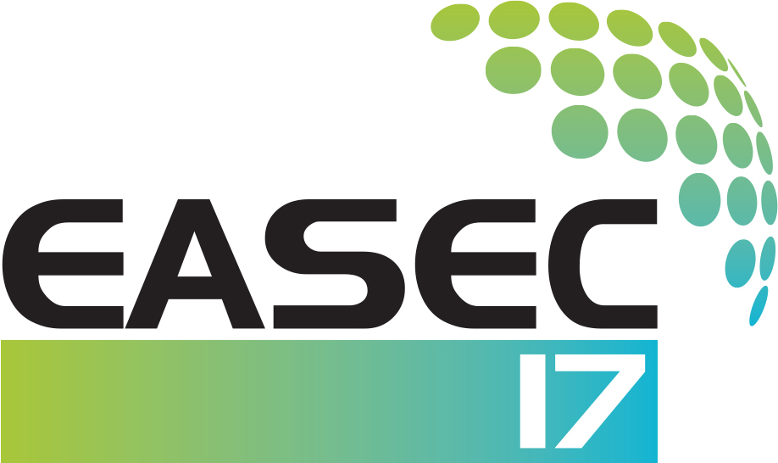 | The 17th East Asia-Pacific Conference on Structural Engineering & Construction  Singapore, June 27-30, 2022

EASEC-17 BEST YOUNG RESEARCHER’S PAPER AWARD FORM

Nominee Information:
Title: Family Name: First Name:
Position: Institution/Organization:
Address:
Tel: Email:

I, hereby, confirm that:
- The nominee is eligible for the EASEC-17 Best Young Researcher’s Paper Award. And,
- The nominee is the first author and presenter of the following full paper:
[Please insert the Paper ID and Full Title here]

Name and signature of Nominator: |  | Date:

Important Notes:
The EASEC-17 Best Young Researcher’s Paper Award is to recognize the best EASEC-17 paper of young researchers (age below 35 years as of 30th June 2022). To be considered for this award, applicants must be the first author and presenter. The completed nomination form must be submitted to EASEC-17@nus.edu.sg by 1 May 2022.

